EXHIBIT XVI

COMPUTATIONAL TOOLS AND INTEGRATED MANAGEMENT SYSTEM

FPSO PETROBRAS XX (P-XX)

SUMMARY

1. OBJECTIVE 3
2. REFERENCE DOCUMENT 3
3. DEFINITIONS 3
4. INTRODUCTION 4
5. SOFTWARE TOOLS GENERAL VIEW 5
6. SCHEDULE 7
7. ENGINEERING 8
8. SUPPLY CHAIN MANAGEMENT TOOL 8
9. MANUFACTURING, CONSTRUCTION AND ASSEMBLY CONTROL TOOLS AND PIPING CONTROL TOOL 9
10. COMMISSIONING TOOL REQUIREMENTS 11
11. ELETRONIC DOCUMENT MANAGEMENT (EDM) 11
12. INTEGRATION 11
13. BUYER SOFTWARE 12
14. EXECUTION PROCEDURE 13
15. DELIVERABLES 14
16. APPENDICES 14

- OBJECTIVE

This document aims to establish guidelines, responsibilities, and requirements to be adopted by SELLER in order to use computational tools and integrated management system.

- REFERENCE DOCUMENT

- I-ET-3000.00-1350-94P-P4X-002 – Digital Engineering Technical Requirements For Detailed Design

- EXHIBIT III – Directives for Product Development

- EXHIBIT V – Directives for Acquisitions

- EXHIBIT VI – Directives for Planning and Control

- EXHIBIT VII – Directives for Quality Assurance System

- EXHIBIT VIII – Directives for Commissioning Process

- DEFINITIONS
For the purposes of this document, the definitions contained on the Agreement and its annexes apply along with the following:

- CAE (Computer Aided Engineering): Represented by “smart software design tools” with their databases and appropriated usage in order to reproduce the same information among different documents and, therefore, reduce inconsistencies in a Project.

- 2D: Generic classifications of elements, drawings, or forms of a two-dimensional or textual nature (Data sheets, flow diagrams, etc.).

- 3D: Three-dimensional representation of elements.

- FIC (Commissioning and Integrated Tool) and Certificare: BUYER’ management Software for Commissioning activities comprising a Database able to generate management and control reports. BUYER, in case of software discontinuity, at any time of this Agreement may provide another software to replace FIC, with the similar features and workflows.

- RO (Occurrence Report): Report intended for recording of progress and occurrences related to the contract execution, issued daily, and signed by representatives of BUYER and SELLER.

- EDM (Electronic Document Management): Tool for management of technical and administrative documents between the SELLER and BUYER.

- RFID (Radio Frequency Identification): Technologies that use radio frequency for data capture.

- WEB application: A client-server computer program that the client (including the user interface and client-side logic) runs in a web browser.

- INTRODUCTION

  - In order to avoid design inconsistencies and improve the data migration from engineering design to procurement, commissioning, construction and assembly, this document lists minimum software and data integration requirements.

  - This document consolidates the minimum information that SELLER shall provide. This information shall be provided as structured information and is listed in the Appendices to this Exhibit.

  - Errors, inaccuracies or omissions detected at any time in the information and quantities presented by the SELLER shall be immediately corrected at no cost to BUYER.

  - SELLER shall dimension technical staff to meet all systems described in this Exhibit such as configuration, implementation, integration, operation and maintenance. The staff for installation and maintenance of these systems shall be mobilized from the beginning of the contract.

  - SELLER shall configure and present all software tool listed in this Exhibit to BUYER within two (2) months from the Agreement Effective Date.

  - BUYER will evaluate all software tools presented by the SELLER, and if the minimum requirements herein listed have not been met, BUYER will request SELLER to make the necessary adjustments.

  - In the case of SELLER share its construction scope with other companies, SELLER shall ensure that all subcontractors also meet the same requirements, using the same tools and updating the information in the same frequency, as those adopted by the SELLER.

- SOFTWARE TOOLS GENERAL VIEW

  - Figure 1 represents a general view of software tools relationships and intends to be used as a reference. The relationships between systems represented in Figure 1 do not need to have exactly the information flow represented if software tools have an automatic integration as indicated in the flowchart.

  - Relationships between the software represented in Figure 1 shall be attained. Would be accepted cases in that one unique software tool contains all minimum requirements of two or more software tools described in this document. Other accepted situation would be of two or more software tools that have all minimum requirements described in only one software tool in this document, in such cases, new relationships shall be established.

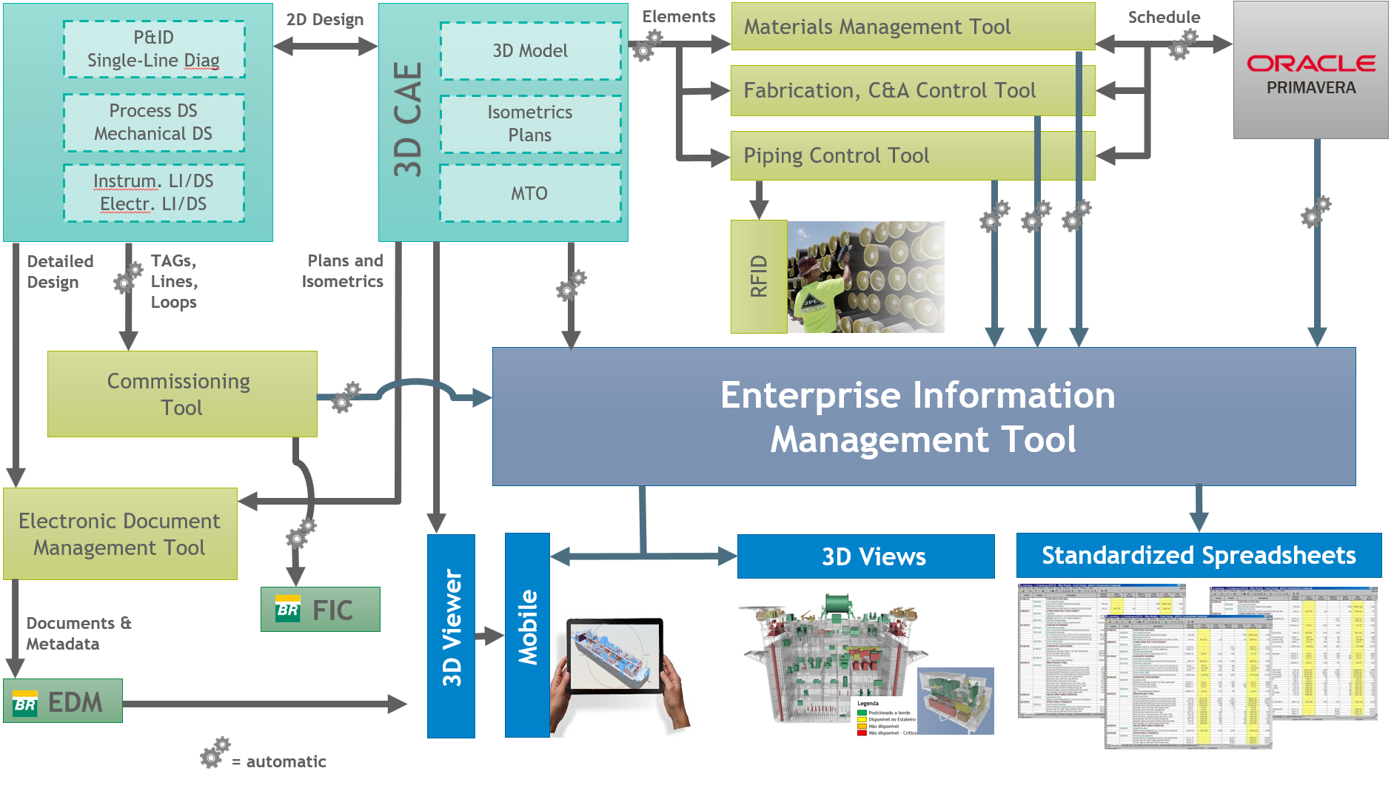
Schedule | Engineering | Control and Management | Integration | Deliverables | BUYER Software
Figure 1 – Systems Integration

  - Software tools are classified into five types:

    - Schedule: SELLER shall use the software specified in this Exhibit.

    - Engineering: SELLER shall choose one software tool that attends the specification in this Exhibit.

    - Control and Management: SELLER may use the software of its choice as long as it provides all the information and meets the requirement of automatic integration with the other software tools, therefore allowing the flow of the applicable data in between the software as described in this Exhibit.

    - Integration: SELLER may choose the software as long as it is a WEB application and that it is able to manage the information described in that Exhibit.

    - BUYER Software: BUYER will be responsible for these software tools and the SELLER shall provide the properly formatted information that will be transferred to these systems.

  - SELLER shall issue its own system architecture with a flowchart of software tools relationships and requirements descriptions for each tool (similar to Figure 1). Additionally, the system architecture shall contain a Data Correlation Matrix which includes, for the Enterprise Information Management Tool, all its data semantic and its correlated data in other software tools that holds relationship. The data Correlation Matrix shall include, at least, but not limited to, all minimum data described in Appendices of this Exhibit.

- SCHEDULE

  - Primavera P6 (16.2 or higher version) software shall be used to elaborate the project schedule.

  - Planning software shall be integrated with Control and Management software tools to allow the issuance of work orders to the field. It shall have a functionality that allow the progresses of Engineering, Manufacturing, Construction and Assembly and Commissioning be registered through mobile devices as smartphones and tablets at all construction sites.

  - Read-only access for Primavera P6 database shall be given to BUYER representatives. The access given should be compatible to security restrictions and technology solutions from BUYER computers standard software configuration.

  - SELLER shall provide to BUYER Primavera P6 one license for each engineering site, hull, modules and two for integration site. The license must allow the possibility to edit the projects.

  - BUYER shall use a digital work order system in which it is possible to have a view of all orders from each discipline construction team through a Plan of work order.

- ENGINEERING

  - The CAE 2D application to be used for engineering design shall be in according to I-ET-3000.00-1350-94P-P4X-002 – Digital Engineering Technical Requirements For Detailed Design.

  - The CAE 3D application to be used for engineering design shall be in according to I-ET-3000.00-1350-94P-P4X-002 – Digital Engineering Technical Requirements For Detailed Design.

- SUPPLY CHAIN MANAGEMENT TOOL

  - Supply chain management tool shall be able to code, publish, retrieve and control all the materials being supplied, such as tagged items, bulk material and spare parts. The tool shall contain at least the information described in Appendix 10 of that Exhibit.

  - Materials description and identification codes shall be loaded automatically from CAE application catalogs to avoid typing errors.

  - The storage and traceability system shall provide visibility of the item/material actual location during storage and shall be updated in real time with each new material input and every time a material is drawn from storage.

  - Inventory Control, information loading and data input regarding each item shall be automated by a scanning type technology in order to guarantee efficient reading and to avoid typing errors for all tagged item and for all pipe materials classified as Full Traceability (FT) according to EXHIBIT VII – Directives for Quality Assurance System:

- SELLER shall use a passive identification TAG (QR Code, Bar Code, RFID, etc.). Tagging technology shall be suitable to environmental and handling conditions to prevent damages;

- SELLER shall provide mobile devices and applications to BUYER for access to all necessary information to certify the traceability of spools and items;

- TAGs attached by welding or by mechanisms that promote mechanical impacts on tubes and pipe fittings is prohibited;

- TAGs shall be preferably provided by the items supplier or distributor and shall already be attached when received by the SELLER;

- In order to maintain traceability TAGs of piping materials, classified as Full Traceability (FT), shall be transferred, by applying new TAGs, when they are cut;

- Immediately upon tack welding of the two first spool components, the incomplete pipe spool shall be tagged (according to item 8.4.a)) in order to identify it, as soon as possible. At the end of the piping fabrication stage, this spool TAG supersedes the original TAGs applied to spool components. The material traceability of the materials and components to the spool shall be documented and kept;

- TAGs shall also be used to provide the necessary inputs for Manufacturing, Construction and Assembly Control Tools and Piping Control Tool.

- MANUFACTURING, CONSTRUCTION AND ASSEMBLY CONTROL TOOLS AND PIPING CONTROL TOOL

  - Manufacturing, construction and assembly activities, whether execution or quality control, shall be controlled by computerized management systems. These systems shall be applied to at least as piping, structures, equipment, electrical, instrumentation and automation, HVAC, telecom discipline.

  - Manufacturing, Construction and Assembly Control Tools shall be able to:

- Perform programming of the activities for each discipline in accordance with the Project Schedule (integration with planning software);

- Control the supply of all inputs necessary for manufacturing, construction and assembly activities for each discipline, and be integrated with the Materials Management System;

- Record and control all execution or quality control activities and all steps applicable to the different disciplines, including sequence of construction tasks;

- Trace all equipment and all inspection and quality control activities in accordance with the EXHIBIT VII – Directives for Quality Assurance System;

- Trace all execution activities in accordance with the contractual requirement;

- It shall have a functionality that allow the inspection and execution data generated in the field be entered through mobile devices.

- Issue reports for all execution and inspection activities. These reports shall contain all information applicable to these activities. It follows the minimum information that the report shall contain:

        - Identification of the item and activity;

        - Date of the activity;

        - Reference documents;

        - Applicable acceptance criteria;

        - Results obtained;

        - Conclusive report;

        - Signature of the professionals responsible for the activity.

  - The SELLER shall update the information required by the Manufacturing, Construction and Assembly Control Tools on a daily basis, i.e. the information recorded on the mobile devices shall be transferred daily to the control applications of each discipline.

  - The Manufacturing, Construction and Assembly Control Tools shall have at least information requested in Appendices 1 to 7. It is SELLER’s responsibility to adapt the registration and control of execution and quality control activities to the peculiarities of each discipline so that characteristic and specific normative and/or contractual test are registered.

  - Access to systems, both for foreman and quality inspectors, shall be controlled through a combining of username and electronic password that ensures the integrity of information and allows securely track of the author who made the update and quality reports generated.

  - The workflow of assembly, cleaning, hydrostatic tests and reassembly documents for piping inspection and test shall be in an electronic form, rather than on paper.

  - The SELLER shall, whenever required, audit the information in the control systems to prevent any failures. BUYER at its sole discretion may also request access to the system to do audit the information.

- COMMISSIONING TOOL REQUIREMENTS

  - According to EXHIBIT VIII – Directives for Commissioning Process, BUYER has its own Commissioning Management Software called FIC (Commissioning and Integration Tool), which will be used to manage the commissioning progress. SELLER may use other commissioning software according to its own criteria, but in this case, SELLER shall perform the database integration between the systems.

  - SELLER shall fill in Commissioning Management Software with the attributes of the Engineering Software Databases (e.g. SPPID, SPI and S3D).

- ELETRONIC DOCUMENT MANAGEMENT (EDM)

  - SELLER shall use a software to manage the engineering documentation and these documents shall also be issue to BUYER EDM.

- INTEGRATION

  - Enterprise Information Management Tool shall be able to visualize data and reporting, regardless of its locations or original software, working as a communication bridge between companies: SELLER and BUYER. This information shall be integrated in an unified and consolidated environment.

  - Read-only access shall be given to BUYER representatives, enabling access to all information applicable to the scope of the contract.

  - Enterprise Information Management Tool shall:

- Be a Web application;

- Contain at least the information requested in Appendixes 1 to 22;

- Allow the 3D Model viewing with weekly update both the engineering model and the execution working progress in field;

- Allow the correlation of engineering elements with its Construction, Assembly and Commissioning documents and execution data;

- Have dashboards for visualization of information;

- Allow generation of export files in spreadsheet format.

- BUYER SOFTWARE

  - BUYER will be responsible for providing, support and training SELLER staff in Software tools listed below for SELLER use during the contract.

  - In case of discontinuation of any BUYER software listed in this section, BUYER will provide a replacing system with similar features and workflows. All requirements indicated will remain valid for the replacing system and shall be complied by SELLER. Database migration to replacing system, if applicable, will be carried out by BUYER.

  - In the case of SELLER share its construction scope with other companies, the SELLER shall guarantee the training of all subcontracted employees, through its own multipliers.

  - Software for financial measurement management

    - SELLER shall fill in an integrated Database, which will basically store data defining the payment milestones and data proving their accomplishment.

  - BUYER Electronic Document Management (EDM)

    - SELLER shall send to BUYER’s EDM all engineering documents issued according to EXHIBIT III – Directives for Product Development. The processes of documentation comment, review and approval by BUYER will be carried out in this tool.

  - Commissioning and Integration Tool (FIC)

    - SELLER shall keep FIC continuously update as a result of field tasks compatible with the physical progress of the commissioning according to EXHIBIT VIII – Directives for Commissioning Process.

  - Occurrence Report (RO)

    - Software tool which aims to comprise a set of information relative to the contract progress which reports all executed activities and shall be accorded by SELLER and BUYER. It will be possible to register service orders, non-conformity notes and all occurrences related to the contract execution, issued daily, and signed by representatives of BUYER and SELLER.

    - SELLER shall keep RO updated daily with front and occurrence information in the field.

  - Punch List Management System

    - SELLER shall answer all pending items registered in BUYER Punch List Management System.

- EXECUTION PROCEDURE

  - A procedure shall be issued detailing:

- Loading engineering data into other systems;
- Loading work progress data into Primavera P6;
- Loading work progress and quality control data into Control and Management Tools;
- Management process for use of passive TAGs for Supply Chain and Manufacture, Construction and Assembly Control.

- DELIVERABLES

  - SELLER shall periodically provide all information described in the Appendices of this Exhibit and 3D model visualization files.

  - Frequency and format of deliveries shall be in accordance with Table 1:

Table 1 - Deliverables
Deliverables | Reference | Frequency | Format
Execution Procedure for Enterprise Information Management Tool | According to item 11 of this Exhibit | Issue within 60 days from contract signature | Adobe (.pdf)
Manufacturing, Construction and Assembly Information | Appendix 01 to 09 of that Exhibit | Daily | Excel (.xml) or input direct in BUYER database
Procurement Information | Appendix 10 of that Exhibit | According to Exhibits
Planning Information | Appendix 11 to 21 of that Exhibit
Schedule | According to Exhibit VI – Directives for Planning and Control |  | *.xer  (Primavera P6 16.2 or higher version)
3D Viewer | According to I-ET-3000.00-1350-94P-P4X-002 – Digital Engineering Technical Requirements For Detailed DesignI
3D Viewer Mobile
3D View | Status according to the standardized colors in Appendix  22 | Weekly (1st working day of the week) | Navisworks (.nwd)

  - The 3D model visualization file can be delivered with status information in a single file or in separate files by status type (Pipe, Structure, Electrical, Supply Status, etc.).

- APPENDICES

  - The following appendices are part of this Exhibit:

- Appendix 01 – Piping Control – Spool
- Appendix 02 – Piping Control – Joint
- Appendix 03 – Piping Support Control
- Appendix 04 – Valves Control
- Appendix 05 – Structure Control
- Appendix 06 – Structure Control - Joint
- Appendix 07 – Equipment Control
- Appendix 08 – Electrical, Instrumentation and Telecom Control
- Appendix 09 – Coating Control
- Appendix 10 – Procurement Control
- Appendix 11 – Engineering Control
- Appendix 12 – Rundown Curves
- Appendix 13 – Physical S Curve
- Appendix 14 – Financial S Curve
- Appendix 15 – Resource Histogram
- Appendix 16 – Executive Summary
- Appendix 17 – Weekly Programming
- Appendix 18 – Weekly Programming – for item
- Appendix 19 – Milestones Control
- Appendix 20 – Risks
- Appendix 21 – Action Plan
- Appendix 22 – KPI
- Appendix 23 – Safety Studies
- Appendix 24 – Standardized Color for 3D model

